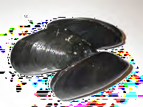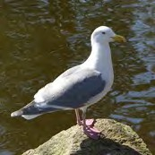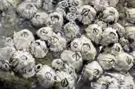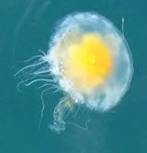

❐

❐

❐

❐

❐

❐

❐

❐

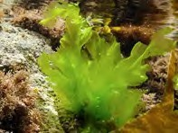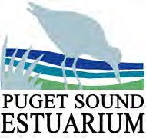Scavenger Hunt Scavenger Hunt

❐

❐

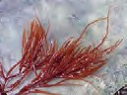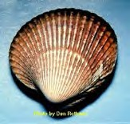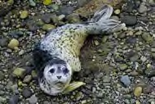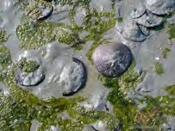

|  |  |  |  |
| --- | --- | --- | --- |
| ❐ | **Sea Lettuce** |  | **Succulent Seaweed** |
| ❐ | **Mussel Shell** |  | **Cockle** |
| ❐ | **Barna- cles** |  | **Crab Molt** |
| ❐ | **Jelly**  **Fish** |  | **Sand Dollar** |
| ❐ | **Seagull** |  | **Harbor Seal** |

|  |  |  |  |
| --- | --- | --- | --- |
| ❐ | **Sea Lettuce** |  | **Succulent Seaweed** |
| ❐ | **Mussel Shell** |  | **Cockle** |
| ❐ | **Barna- cles** |  | **Crab Molt** |
| ❐ | **Jelly**  **Fish** |  | **Sand Dollar** |
| ❐ | **Seagull** |  | **Harbor Seal** |