Does an Oyster Have a Heart?
Answer Key

Name:
Complete the table below with the help of the oyster diagram:

Date: _

Body Part Name | Letter | Body Part Name | Letter
Shell | A | Labial Palps (L.P) | D
Sensory Tentacles | I | Hinge | B
Gills | J | Stomach | F
Mantle | C | Heart | G
Adductor Muscle | H | Anus | E

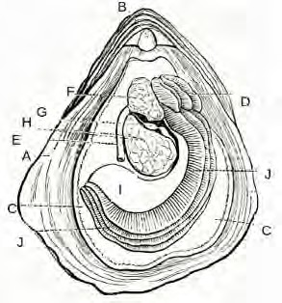
I

What would you find inside the stomach of the oyster? Plankton and detritions.

What function does the adductor muscle serve? Close and hold the two shells together.

Why are oysters important for our estuaries? They filter and clean out waters.

