Does an Oyster Have a Heart? Student Activity Worksheet

Name: Date: _

Complete the table below with the help of the oyster diagram:
Body Part Name | Letter | Body Part Name | Letter
Shell |  | Labial Palps (L.P)
Sensory Tentacles |  | Hinge
Gills |  | Stomach
Mantle |  | Heart
Adductor Muscle |  | Anus

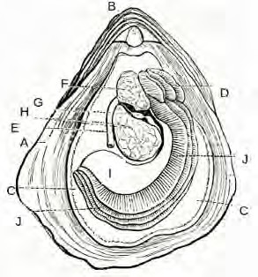
I

What would you find inside the stomach of the oyster? What function does the adductor muscle serve?
Why are oyster important for our estuaries?

Oyster anatomy

(inte rnal anatomy ly ing in
left or lower valve)

-= ►_

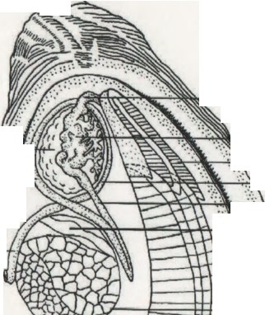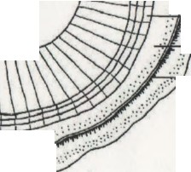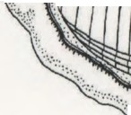Anterior

Digestive /
gland ./· )!"l'
'
, Esop ha g u s

- , r-- - Slomach
" +,
Labial palps

Ascending intestine .
..
.:.·
/·
.._\.
..'•

. ,·...
Descending intestine

Dorsal
...::
....
.....-.
,.
,.:'•·..
....'..•.:
...
.. I: ::\ Style sac - midgut
··:.:_. , eart
·: ,:

Rectum
Anus
.,..
......
.
.......
.·'..
··.•
....
.
.....
..
  - ..l."·....
'.·:..
•..'••..•.• I
.•:.
...:....
:..:.
..

Ventral

. .'
Cloaca ! .-.:"· .( ..

chamber .. '· ;,
....
..:."
...
..
.
'
·...:..
.....
..

,.

Adductor muscle

Gills

,' .
ir:•.•;,•:·y·•·
.....
:•:
::'
f .ii/
Mantle

" . ·ir I I I 1 I I I 1 I I {\\
--
.·· ..-.-.------. .....

.. .'
M l \ it;
'

- .•·.•"/ Sensory tentacles

::• " ', •,',"•,'\I.' ',• ;. • t ' • •• • •.
:, • - ' , 'l' , \·

P o sterior 0 Cenilmete-s 5
.rigun: I. Oyster in 1,:ft valve showing caroinal axes a.nd digc.1:ivc system including labial palps and gills. Rcdr.iwn from Galrsoff'(1964).
Redrawn from Galtsoff (1964)

