Name:
From Plankton to Orcas
Answer Key

Date: _

- What is a food chain?

Food chains are how organisms are related to each other by the food they eat.
- What is a food web?

A food web shows the flow of energy through a system, such as an estuary, and it begins with the sun.
- Draw a food web found in the Puget Sound:
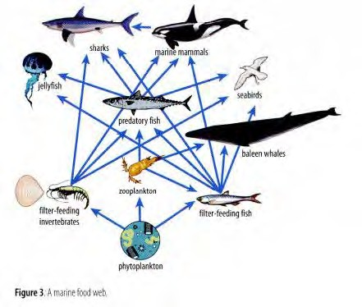

- What is a keystone species? Name one local marine animal that is a keystone species and why.

A keystone species is one that has a greater impact on a food web than you would expect in relation to their abundance. Sea otters are a keystone species. Without them urchin population are not in check and then kelp forests are depleted.

- What are some possible disruptions to the food web that would cause issues with energy flow? Low biodiversity, loss of apex predator, loss of keystone species, low number of producers, etc.
From Plankton to Orcas | Student Guide

