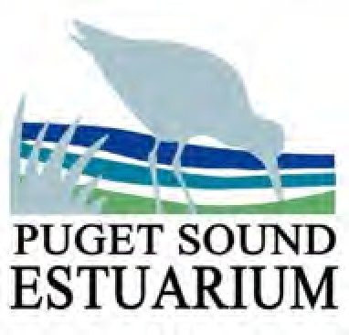
Name:
From Plankton to Orcas
Student Activity

Date: _

- What is a food chain?

- What is a food web?

- Draw a food web found in the Puget Sound:

- What is a keystone species? Name one local marine animal that is a keystone species and why.

- What are some possible disruptions to the food web that would cause issues with energy flow?

From Plankton to Orcas | Student Guide

