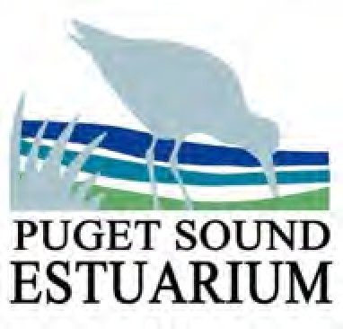
How Healthy is the Sound?
Student Activity

Name: Date: _

- Based on the data collected on the water quality of your estuary, how healthy would you describe the water quality to be?

  - What are some healthy water quality parameters? Why?

  - What are some concerning water quality parameters? Why?

- Where does the excess nitrate come from?

- What does high levels of phosphate lead to?

- Why does salinity vary in estuaries?

- What can you do to help improve the water quality of your estuary?

How Healthy is the Sound? | Student Activity

