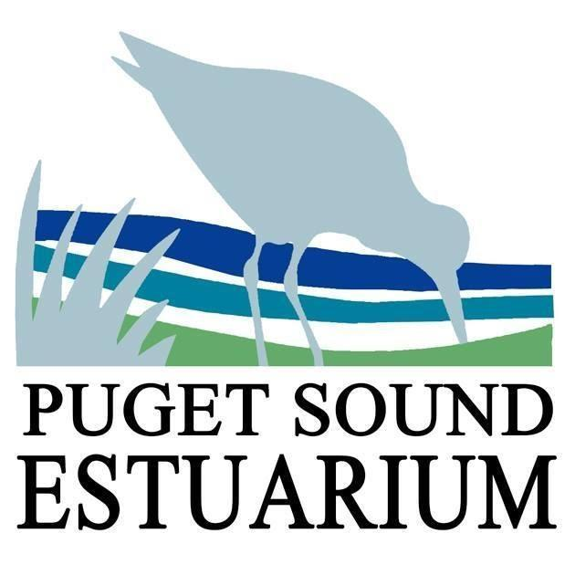
Oysters and Estuaries
Student Activity Worksheet
Name: ____________________ Date: ______________

- Who were the first inhabitants of the Deschutes estuary and Budd Inlet?

- Why was the Olympia Oyster so important to the people of area?

- List three locations or business that are built on land created by dredged fill.

a.

b.

c.

- What was Little Hollywood?
  - Olympia’s first film theater.
  - The name of the neighborhood where the famous people of Olympia lived.
  - A shantytown of house boats built on Capitol Lake.

- How will Olympia’s current shoreline be impacted by sea level rise?

