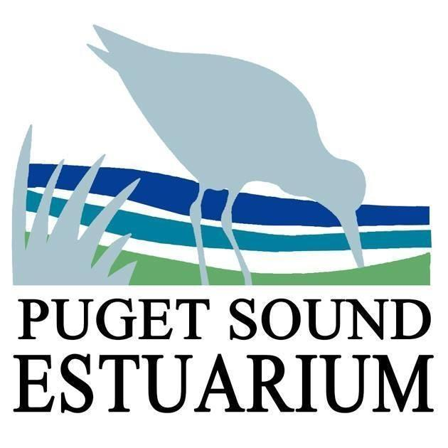
Salinity
Name:__________________ Teacher:____________________ Date:______________

- What is a salt marsh?

- What is the name of the environment where freshwater and saltwater mix?

- What is salinity?

What are the salinity percentages of…
Ocean ____________ Puget Sound __________ Johns Creek __________
Vegetation Notes | Transect Plot | Soil Salinity Level  (ppt – parts per thousand)
 |  | 10/16/2015 | 5/24/2016 | 5/24/2017 | 8/22/2018
Upland | 1 | 0.07 | 0.04 | 0.04 | 0.06
 | 2 | 0.04 | 0.15 | 0.04 | 0.04
Soil Berm Location | 3 | 0.20 | 2.33 | 0.2 | 2.36
 | 4 | 0.80 | 3.6 | 1.9 | 3.23
Marsh | 5 | 1.4 | 3.5 | 1 | 5.03
- Based on the data table, what happened when the soil berm was removed in 2015?
Claim:

Evidence:

Reasoning:

